Q1 WAP to print following pattern without println(). Use System.out.print(). [Hint: you can use escape sequence)

1. \* 2. \*

\* \* \* \*

\* \* \* \* \* \*

\* \* \* \*

\* \*

Q2 WAP to convert inches to Foot. (Given is 61.8 inches)

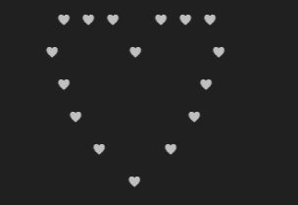Q3. WAP to print following Heart pattern [Hint: use only multiple System.out.println() statements and use Unicode sequence for heart symbol]

